CBI — Veeam Backup for Microsoft 365
Monthly Backup Report — 2026-04
M365 tenant: cbinteriorsdba.onmicrosoft.com
Report generated: 2026-05-02 18:21
Executive Summary
21 M365 users in this tenant are protected by Veeam Backup for Microsoft 365. Total backup storage in use is 350.22 GB across 1 repository, with 1 active backup job. This report breaks down storage by Microsoft 365 service, lists per-user backup coverage, and projects how storage will grow over the next 12 months.
21  M365 Users | 11  Users w/ OneDrive backed up | 350.22 GB  Backup Storage Used | 1  Backup Jobs (Running)
Backup Posture
Job | Backup Type | Last Run | Status | Enabled | Next Run
CBI-O365 | EntireOrganization | 2026-05-02T08:42:48.8187376Z | Running | Yes | 2026-05-02T20:10:00Z
Backup repositories:
Repository | Used | Capacity | Free | Path
CBI-O365 | 350.22 GB | 1023.98 GB | 671.18 GB | C:\O365 Backups\bkp_CBI-365

Storage by M365 Module
Per-module bytes are estimated by attributing the tenant's total used backup storage in proportion to how often each service appeared in restore points over the last 90 days, weighted by industry-default ratios. For exact per-mailbox / per-site sizes, run the VB365 PowerShell module (Get-VBOEntityData).
Module | Estimated Storage | Share of Total | RP coverage (last 90d)
Exchange | 194.10 GB | 55.4% | 3,583 / 3,594
OneDrive | 86.68 GB | 24.8% | 3,520 / 3,594
SharePoint | 52.11 GB | 14.9% | 3,527 / 3,594
Teams | 17.33 GB | 5.0% | 3,519 / 3,594
Per-User Backup Coverage
21 users in the M365 directory. Mailbox coverage is set Yes for every user when the job is EntireOrganization (current setting). OneDrive coverage is determined by probing /users/{id}/onedrives.
Display Name | Email | Mailbox | OneDrive
enjoytheride | enjoytheride@cbinteriors.net | Yes | No
Jennifer Jenike | jennifer.j@cbinteriors.net | Yes | Yes
Mike Surmanian | MikeSurmanian@cbinteriors.net | Yes | No
Patty Austin | Patty.a@cbinteriors.net | Yes | No
CBFI Admin | cbfadmin@cbinteriors.net | Yes | No
Erica Cardenalli | erica.c@cbinteriors.net | Yes | Yes
Renee Darling | Renee.D@cbinteriors.net | Yes | Yes
Andy Stasch | andy.s@cbinteriors.net | Yes | Yes
Katy Kimari | katy.k@cbinteriors.net | Yes | Yes
Backup Admin Uv2b | backupadminUv2b@cbinteriors.net | Yes | No
Discovery Search Mailbox | DiscoverySearchMailbox{D919BA05-46A6-415f-80AD-7E09334BB852}@cbinteriorsdba.onmicrosoft.com | Yes | No
Jason Weiner | Jason.w@cbinteriors.net | Yes | Yes
Amanda Kennedy | Amanda.k@cbinteriors.net | Yes | Yes
Troy Kenney | troy.k@cbinteriors.net | Yes | No
Tiffany George | tiffany.g@cbinteriors.net | Yes | Yes
Technijian Support | technijian@cbinteriors.net | Yes | Yes
Andy Busher | andy.b@cbinteriors.net | Yes | Yes
Amber Summers-Santos | Amber.s@cbinteriors.net | Yes | Yes
CBI Purchasing | purchasing@cbinteriors.net | Yes | No
Jorge Chavez | jorge.c@cbinteriors.net | Yes | No
CBI Scheduling | scheduling@cbinteriors.net | Yes | No

Storage Trend & Projection
Projection method: industry default 4% MoM (will refine after 2+ monthly snapshots). Compound monthly growth rate used: 4.00%.
Horizon | Projected Storage | Δ vs today
Today (snapshot) | 350.22 GB | —
+3 months | 393.95 GB | +43.73 GB
+6 months | 443.14 GB | +92.92 GB
+9 months | 498.47 GB | +148.25 GB
+12 months | 560.71 GB | +210.49 GB
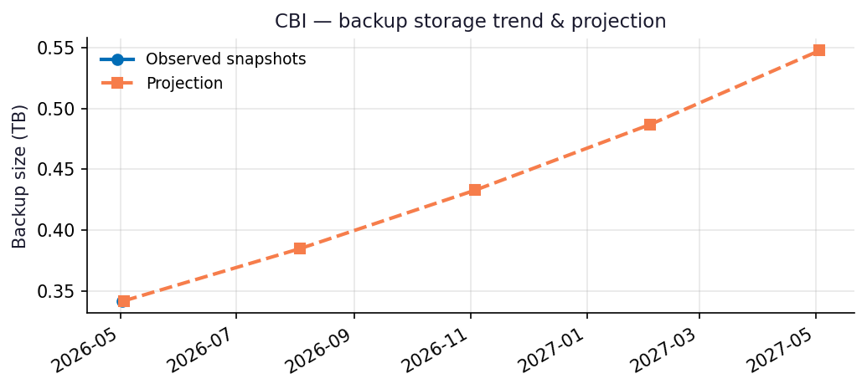
Recommendations
- Repository CBI-O365 is 34% full (671.18 GB free of 1023.98 GB capacity).
- Run this report monthly. The projection accuracy improves with each snapshot — after 3 snapshots the linear-regression fit replaces the industry-default growth assumption.

Appendix: Methodology & Data Sources
Data sources
- Veeam Backup for Microsoft 365 REST API at https://10.7.9.227:4443/v8 (OAuth2 password grant; self-signed TLS).
- Endpoints used: /Organizations, /Organizations/{id}/usedRepositories, /Organizations/{id}/users, /Organizations/{id}/users/{uid}/onedrives, /BackupRepositories, /Jobs, /RestorePoints?backupTimeFrom=...
Per-module attribution caveat
REST does not expose per-mailbox or per-OneDrive backup byte counts on this build. Per-module estimates reweight the total used storage by the share of restore points (over the trailing 90 days) that included each service. Treat the numbers as informed estimates, not invoiced figures. For ground-truth per-user/per-team sizes use the VB365 PowerShell module Get-VBOEntityData.
Trend projection
- With <2 monthly snapshots: project at 4%/month compound.
- With ≥2 snapshots: linear regression on log(bytes) over time.

